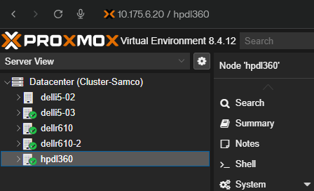

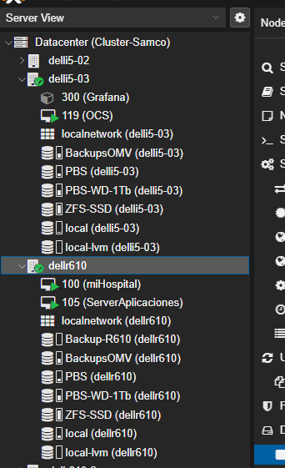

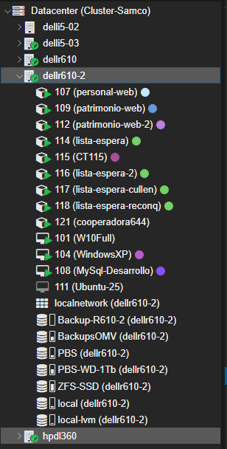

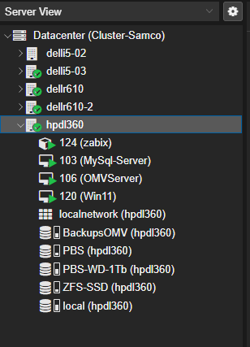

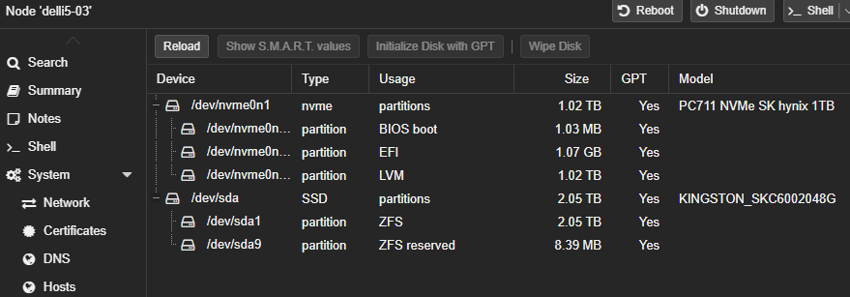
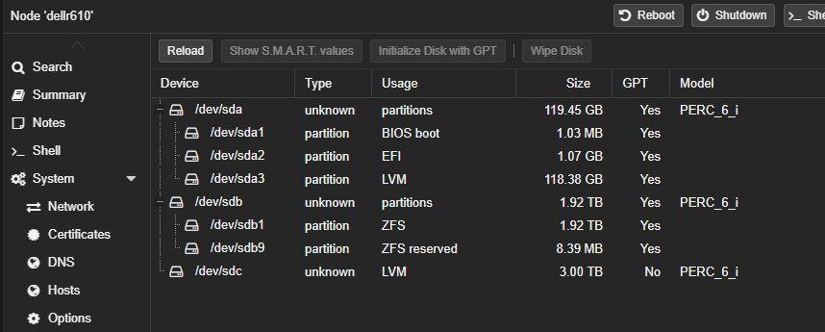
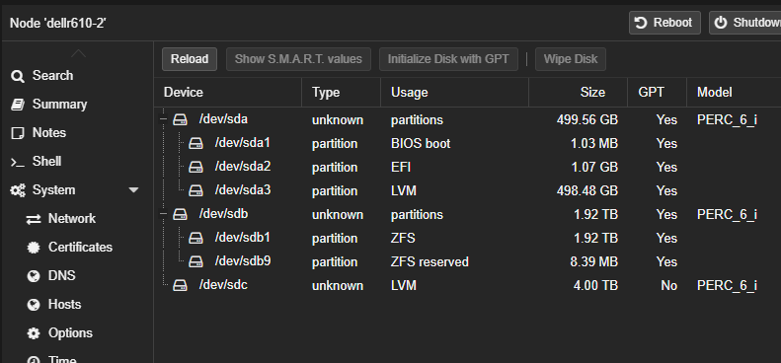

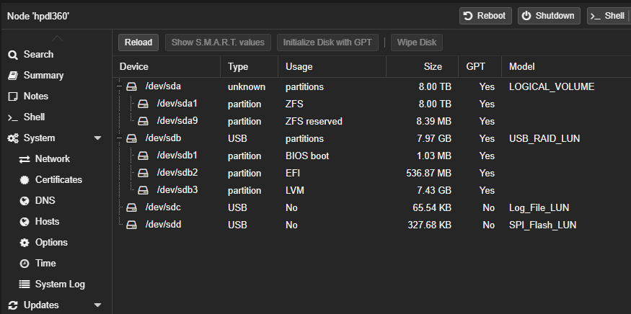
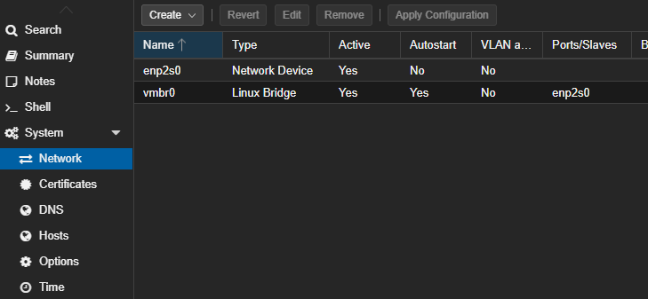
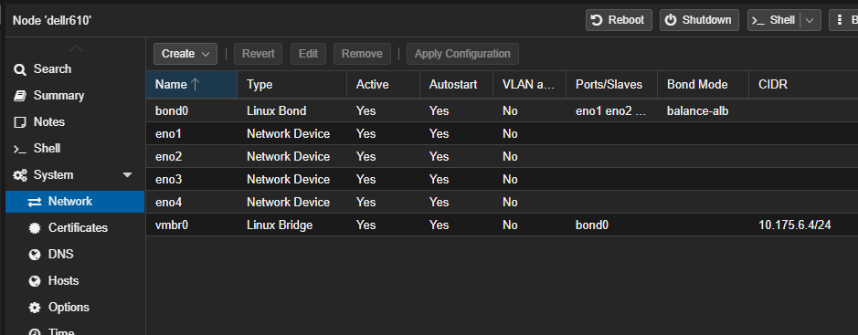

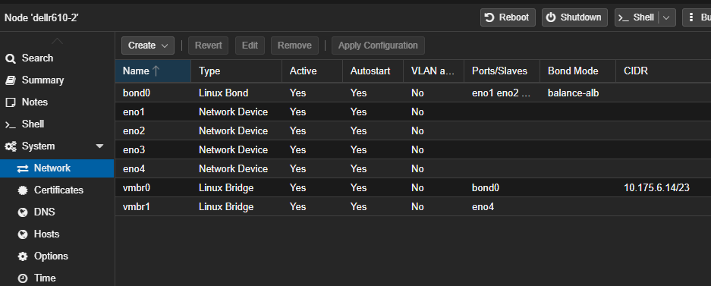
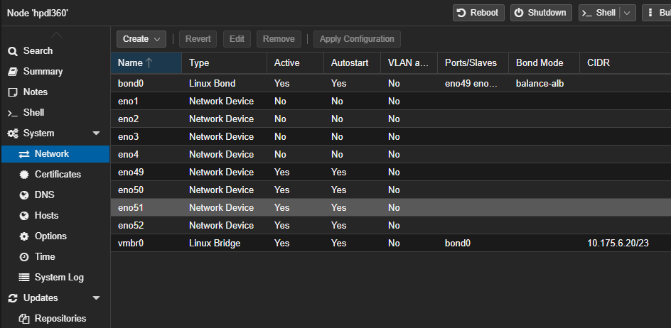

root@delli5-03:~# echo "--- MODELO Y DISCOS FISICOS ---" && lsblk -do NAME,SIZE,MODEL,ROTA && \
echo "--- PARTICIONES Y FILSYSTEM ---" && lsblk -f && \
echo "--- ESTADO DE ZFS (Si aplica) ---" && zpool status 2>/dev/null || echo "No usa ZFS" && \
echo "--- ESTADO DE LVM (Si aplica) ---" && vgs && lvs
--- MODELO Y DISCOS FISICOS ---
NAME SIZE MODEL ROTA
sda 1.9T KINGSTON SKC6002048G 0
sr0 1024M HL-DT-ST DVD+/-RW GU90N 1
zd0 100G 0
zd16 700G 0
zd32 200G 0
zd48 40G 0
zd64 100G 0
nvme0n1 953.9G PC711 NVMe SK hynix 1TB 0
--- PARTICIONES Y FILSYSTEM ---
NAME FSTYPE FSVER LABEL UUID FSAVAIL FSUSE% MOUNTPOINTS
sda
├─sda1 zfs_me 5000 ZFS-SSD 11997217387869938899
└─sda9
sr0
zd0
├─zd0p1
├─zd0p2 vfat FAT32 25D3-E6B5
└─zd0p3 ext4 1.0 5c9fb453-2c7c-435f-9216-18d50d85c817
zd16
└─zd16p1
ext4 1.0 cfeb33f3-8c6c-4830-aa1a-c872ea1f4556
zd32
├─zd32p1
│ ntfs Reservado para el sistema
│ 00487E05487DF9AC
├─zd32p2
│ ntfs 34908001907FC83E
└─zd32p3
ntfs F4F6EA34F6E9F730
zd48
├─zd48p1
│ ext4 1.0 6f9baed3-bc9e-46a1-b311-a6a08c44f670
├─zd48p2
│
└─zd48p5
swap 1 2b86550c-ccc4-4045-a2aa-c21eae72d571
zd64
├─zd64p1
│ ext4 1.0 4434796d-81b9-4cee-8b2f-bfef13ef2883
├─zd64p2
│
└─zd64p5
swap 1 0f95c0a3-d2d2-4756-a73f-619a288738d9
nvme0n1
├─nvme0n1p1
│
├─nvme0n1p2
│ vfat FAT32 BB25-B9F6 1010.3M 1% /boot/efi
└─nvme0n1p3
LVM2_m LVM2 IJV34R-l75c-AVrJ-haJv-HJg1-BDBR-5j7YYh
├─pve-swap
│ swap 1 16d0d080-a46f-4101-af70-785d0d996e4d [SWAP]
├─pve-root
│ ext4 1.0 5848c99f-bfad-4ea9-9ea7-cee972b35dcb 81.6G 8% /
├─pve-data_tmeta
│
│ └─pve-data-tpool
│
│ └─pve-data
│
└─pve-data_tdata

└─pve-data-tpool

└─pve-data

--- ESTADO DE ZFS (Si aplica) ---
pool: ZFS-SSD
state: ONLINE
scan: scrub repaired 0B in 00:27:04 with 0 errors on Sun Mar 8 00:51:05 2026
config:

NAME STATE READ WRITE CKSUM
ZFS-SSD ONLINE 0 0 0
ata-KINGSTON_SKC6002048G_50026B7785664C83 ONLINE 0 0 0

errors: No known data errors
--- ESTADO DE LVM (Si aplica) ---
VG #PV #LV #SN Attr VSize VFree
pve 1 3 0 wz--n- <952.87g 16.00g
LV VG Attr LSize Pool Origin Data% Meta% Move Log Cpy%Sync Convert
data pve twi-aotz-- <816.21g 0.00 0.23
root pve -wi-ao---- 96.00g
swap pve -wi-ao---- 8.00g
root@delli5-03:~#

root@dellr610:~# echo "--- MODELO Y DISCOS FISICOS ---" && lsblk -do NAME,SIZE,MODEL,ROTA && \
echo "--- PARTICIONES Y FILSYSTEM ---" && lsblk -f && \
echo "--- ESTADO DE ZFS (Si aplica) ---" && zpool status 2>/dev/null || echo "No usa ZFS" && \
echo "--- ESTADO DE LVM (Si aplica) ---" && vgs && lvs
--- MODELO Y DISCOS FISICOS ---
NAME SIZE MODEL ROTA
sda 111.3G PERC 6/i 1
sdb 1.7T PERC 6/i 1
sdc 2.7T PERC 6/i 1
sr0 1024M MATSHITA DVD-ROM UJ8E0B 1
zd0 86G 0
zd32 100G 0
zd80 100G 0
zd96 700G 0
zd112 537G 0
--- PARTICIONES Y FILSYSTEM ---
NAME FSTYPE FSVER LABEL UUID FSAVAIL FSUSE% MOUNTPOINTS
sda
├─sda1
├─sda2 vfat FAT32 D6E3-1EBC
└─sda3 LVM2_m LVM2 W7qZKJ-RzUE-seaV-zDVZ-GNls-9wPC-37tbsh
├─pve-swap swap 1 9fa7ab04-658d-4fd0-836d-5292c35abedc [SWAP]
├─pve-root ext4 1.0 b273af5d-0f46-4697-afe8-04d7840019df 24.9G 27% /
├─pve-data_tmeta
│
│ └─pve-data
└─pve-data_tdata

└─pve-data
sdb
├─sdb1 zfs_me 5000 ZFS-SSD
│ 4686420515717641592
└─sdb9
sdc LVM2_m LVM2 UsdKts-Utd5-Djrq-Wv85-yncd-VxxU-evOK0T
├─Backup--R610-Backup--R610_tmeta
│
│ └─Backup--R610-Backup--R610-tpool
│
│ └─Backup--R610-Backup--R610
│
└─Backup--R610-Backup--R610_tdata

└─Backup--R610-Backup--R610-tpool

└─Backup--R610-Backup--R610

sr0
zd0
├─zd0p1 ext4 1.0 1ec15c6e-137f-44f4-9f5f-e2f7a472aec4
├─zd0p2
└─zd0p5 swap 1 bba25f09-409e-4d12-b23c-4d8eb85a0495
zd32
├─zd32p1 ext4 1.0 4434796d-81b9-4cee-8b2f-bfef13ef2883
├─zd32p2
└─zd32p5 swap 1 0f95c0a3-d2d2-4756-a73f-619a288738d9
zd80
├─zd80p1
├─zd80p2 vfat FAT32 25D3-E6B5
└─zd80p3 ext4 1.0 5c9fb453-2c7c-435f-9216-18d50d85c817
zd96
└─zd96p1 ext4 1.0 cfeb33f3-8c6c-4830-aa1a-c872ea1f4556
zd112
├─zd112p1 ext4 1.0 0048776c-2eb2-4d5a-9a2d-52996b5652ab
├─zd112p2
├─zd112p5 swap 1 0ec2153e-fb36-48b8-8e27-bca45650697d
├─zd112p6 ext4 1.0 a17b520a-9138-4e8b-97eb-f2d349352502
└─zd112p7 ext4 1.0 4738262b-c472-462c-9814-4672fb850475
--- ESTADO DE ZFS (Si aplica) ---
pool: ZFS-SSD
state: ONLINE
scan: scrub repaired 0B in 02:24:42 with 0 errors on Sun Mar 8 02:48:43 2026
config:

NAME STATE READ WRITE CKSUM
ZFS-SSD ONLINE 0 0 0
scsi-360026b905c742c002d00852758263ce2 ONLINE 0 0 0

errors: No known data errors
--- ESTADO DE LVM (Si aplica) ---
VG #PV #LV #SN Attr VSize VFree
Backup-R610 1 1 0 wz--n- <2.73t 376.00m
pve 1 3 0 wz--n- <110.25g 13.75g
LV VG Attr LSize Pool Origin Data% Meta% Move Log Cpy%Sync Convert
Backup-R610 Backup-R610 twi-aotz-- <2.70t 0.00 0.17
data pve twi-a-tz-- 48.93g 0.00 1.59
root pve -wi-ao---- <37.56g
swap pve -wi-ao---- 8.00g
root@dellr610:~#

root@dellr610-2:~# echo "--- MODELO Y DISCOS FISICOS ---" && lsblk -do NAME,SIZE,MODEL,ROTA && \
echo "--- PARTICIONES Y FILSYSTEM ---" && lsblk -f && \
echo "--- ESTADO DE ZFS (Si aplica) ---" && zpool status 2>/dev/null || echo "No usa ZFS" && \
echo "--- ESTADO DE LVM (Si aplica) ---" && vgs && lvs
--- MODELO Y DISCOS FISICOS ---
NAME SIZE MODEL ROTA
sda 465.3G PERC 6/i 1
sdb 1.7T PERC 6/i 1
sdc 3.6T PERC 6/i 1
sdd 0B Virtual Floppy 1
sde 0B LCDRIVE 1
sr0 1024M Virtual CD 1
zd0 32G 0
zd16 4M 0
zd32 100G 0
zd48 200G 0
zd64 537G 0
zd80 1M 0
zd96 537G 0
zd112 100G 0
--- PARTICIONES Y FILSYSTEM ---
NAME FSTYPE FSVER LABEL UUID FSAVAIL FSUSE% MOUNTPOINTS
sda
├─sda1
├─sda2 vfat FAT32 87D0-0E44
└─sda3 LVM2_m LVM2 ZfYI1D-NdZx-x3uE-ckRK-Ejde-AkLR-E7aS6C
├─pve-swap
│ swap 1 b556400c-3bda-4074-991f-0f0fec27b7cd [SWAP]
├─pve-root
│ ext4 1.0 a3975344-2bea-4e30-bfe5-8f58d0faa0e5 74.6G 15% /
├─pve-data_tmeta
│
│ └─pve-data-tpool
│
│ ├─pve-data
│ │
│ ├─pve-vm--104--disk--0
│ │
│ └─pve-vm--115--disk--0
│ ext4 1.0 8f6f4a7f-805a-4c5c-b71c-1452c0c151d0
└─pve-data_tdata

└─pve-data-tpool

├─pve-data
│
├─pve-vm--104--disk--0
│
└─pve-vm--115--disk--0
ext4 1.0 8f6f4a7f-805a-4c5c-b71c-1452c0c151d0
sdb
├─sdb1 zfs_me 5000 ZFS-SSD 14196692725506263851
└─sdb9
sdc LVM2_m LVM2 W2WdeU-19si-8vJh-yzO6-riQ9-EgKd-eiUA7b
├─Backup--R610--2-backup--thin--pool_tmeta
│
│ └─Backup--R610--2-backup--thin--pool
│
└─Backup--R610--2-backup--thin--pool_tdata

└─Backup--R610--2-backup--thin--pool

sdd
sde
sr0
zd0
zd16
zd32
├─zd32p1 vfat FAT32 FA9E-C21F
├─zd32p2
├─zd32p3 ntfs 0C5AA0615AA048F2
└─zd32p4 ntfs B06601FB6601C2D8
zd48
├─zd48p1 ntfs Reservado para el sistema
│ 00487E05487DF9AC
├─zd48p2 ntfs 34908001907FC83E
└─zd48p3 ntfs F4F6EA34F6E9F730
zd64
├─zd64p1 ext4 1.0 0048776c-2eb2-4d5a-9a2d-52996b5652ab
├─zd64p2
├─zd64p5 swap 1 0ec2153e-fb36-48b8-8e27-bca45650697d
├─zd64p6 ext4 1.0 a17b520a-9138-4e8b-97eb-f2d349352502
└─zd64p7 ext4 1.0 4738262b-c472-462c-9814-4672fb850475
zd80
zd96
├─zd96p1 ext4 1.0 0048776c-2eb2-4d5a-9a2d-52996b5652ab
├─zd96p2
├─zd96p5 swap 1 0ec2153e-fb36-48b8-8e27-bca45650697d
├─zd96p6 ext4 1.0 a17b520a-9138-4e8b-97eb-f2d349352502
└─zd96p7 ext4 1.0 4738262b-c472-462c-9814-4672fb850475
zd112
├─zd112p1
│
└─zd112p2
ext4 1.0 f12c59c1-c48f-4c42-90e0-8bcf8057fdf4
--- ESTADO DE ZFS (Si aplica) ---
pool: ZFS-SSD
state: ONLINE
scan: scrub repaired 0B in 01:14:11 with 0 errors on Sun Mar 8 01:38:12 2026
config:

NAME STATE READ WRITE CKSUM
ZFS-SSD ONLINE 0 0 0
scsi-36782bcb01a57fb002fc31eeb10d936c0 ONLINE 0 0 0

errors: No known data errors
--- ESTADO DE LVM (Si aplica) ---
VG #PV #LV #SN Attr VSize VFree
Backup-R610-2 1 1 0 wz--n- <3.64t 0
pve 1 5 0 wz--n- <464.25g 16.00g
LV VG Attr LSize Pool Origin Data% Meta% Move Log Cpy%Sync Convert
backup-thin-pool Backup-R610-2 twi-a-tz-- <3.64t 0.00 10.41
data pve twi-aotz-- <337.36g 11.74 0.81
root pve -wi-ao---- 96.00g
swap pve -wi-ao---- 8.00g
vm-104-disk-0 pve Vwi-aotz-- 32.00g data 100.00
vm-115-disk-0 pve Vwi-aotz-- 8.00g data 94.94
root@dellr610-2:~#

root@hpdl360:~# echo "--- MODELO Y DISCOS FISICOS ---" && lsblk -do NAME,SIZE,MODEL,ROTA && \
echo "--- PARTICIONES Y FILSYSTEM ---" && lsblk -f && \
echo "--- ESTADO DE ZFS (Si aplica) ---" && zpool status 2>/dev/null || echo "No usa ZFS" && \
echo "--- ESTADO DE LVM (Si aplica) ---" && vgs && lvs
--- MODELO Y DISCOS FISICOS ---
NAME SIZE MODEL ROTA
sda 7.3T LOGICAL VOLUME 1
sdb 7.4G USB RAID LUN 1
sdc 64K Log File LUN 1
sdd 320K SPI Flash LUN 1
sr0 1024M hp DVDRW GUD0N 1
zd0 40G 0
zd16 4M 0
zd48 100G 0
zd64 100G 0
zd96 537G 0
zd112 1M 0
zd144 700G 0
--- PARTICIONES Y FILSYSTEM ---
NAME FSTYPE FSVER LABEL UUID FSAVAIL FSUSE% MOUNTPOINTS
sda
├─sda1 zfs_mem 5000 ZFS-SSD 2705496116053608495
└─sda9
sdb
├─sdb1
├─sdb2 vfat FAT32 DBF9-08BC 499.3M 2% /boot/efi
└─sdb3 LVM2_me LVM2 0 SAPjdZ-JMrv-dsRf-TuMG-x0lU-WZzc-l2x9lo
├─pve-swap swap 1 7503b418-015a-46c6-8a70-6fb2e98b2af4 [SWAP]
└─pve-root ext4 1.0 5ed19344-2504-4cca-b147-31c1e70b081a 2G 62% /
sdc
sdd
sr0
zd0
├─zd0p1 ext4 1.0 6f9baed3-bc9e-46a1-b311-a6a08c44f670
├─zd0p2
└─zd0p5 swap 1 2b86550c-ccc4-4045-a2aa-c21eae72d571
zd16
zd48
├─zd48p1 ext4 1.0 4434796d-81b9-4cee-8b2f-bfef13ef2883
├─zd48p2
└─zd48p5 swap 1 0f95c0a3-d2d2-4756-a73f-619a288738d9
zd64
├─zd64p1 vfat FAT32 FA9E-C21F
├─zd64p2
├─zd64p3 ntfs 0C5AA0615AA048F2
└─zd64p4 ntfs B06601FB6601C2D8
zd96
├─zd96p1 ext4 1.0 0048776c-2eb2-4d5a-9a2d-52996b5652ab
├─zd96p2
├─zd96p5 swap 1 0ec2153e-fb36-48b8-8e27-bca45650697d
├─zd96p6 ext4 1.0 a17b520a-9138-4e8b-97eb-f2d349352502
└─zd96p7 ext4 1.0 4738262b-c472-462c-9814-4672fb850475
zd112
zd144
└─zd144p1 ext4 1.0 cfeb33f3-8c6c-4830-aa1a-c872ea1f4556
--- ESTADO DE ZFS (Si aplica) ---
pool: ZFS-SSD
state: ONLINE
scan: scrub repaired 0B in 00:29:21 with 0 errors on Sun Mar 8 00:53:22 2026
config:

NAME STATE READ WRITE CKSUM
ZFS-SSD ONLINE 0 0 0
scsi-3600508b1001c56ac641c0833eaa33376 ONLINE 0 0 0

errors: No known data errors
--- ESTADO DE LVM (Si aplica) ---
VG #PV #LV #SN Attr VSize VFree
pve 1 2 0 wz--n- <6.92g 4.00m
LV VG Attr LSize Pool Origin Data% Meta% Move Log Cpy%Sync Convert
root pve -wi-ao---- 6.16g
swap pve -wi-ao---- 768.00m
root@hpdl360:~#

root@hpdl360:~# echo "--- LISTADO DE VMS Y ESTADO ---" && qm list && \
echo "--- CONFIGURACION DE RED DEL HOST ---" && cat /etc/network/interfaces
--- LISTADO DE VMS Y ESTADO ---
VMID NAME STATUS MEM(MB) BOOTDISK(GB) PID
103 MySql-Server running 6144 537.00 71507
106 OMVServer running 4128 100.00 71866
120 Win11 running 4096 100.00 740790
--- CONFIGURACION DE RED DEL HOST ---
# network interface settings; autogenerated
# Please do NOT modify this file directly, unless you know what
# you're doing.
#
# If you want to manage parts of the network configuration manually,
# please utilize the 'source' or 'source-directory' directives to do
# so.
# PVE will preserve these directives, but will NOT read its network
# configuration from sourced files, so do not attempt to move any of
# the PVE managed interfaces into external files!

auto lo
iface lo inet loopback

auto eno52
iface eno52 inet manual

iface eno1 inet manual

iface eno2 inet manual

iface eno3 inet manual

iface eno4 inet manual

auto eno49
iface eno49 inet manual

auto eno50
iface eno50 inet manual

auto eno51
iface eno51 inet manual

auto bond0
iface bond0 inet manual
bond-slaves eno49 eno50 eno51 eno52
bond-miimon 100
bond-mode balance-alb

auto vmbr0
iface vmbr0 inet static
address 10.175.6.20/23
gateway 10.175.6.201
bridge-ports bond0
bridge-stp off
bridge-fd 0

source /etc/network/interfaces.d/*
root@hpdl360:~#

root@dellr610-2:~# echo "--- LISTADO DE VMS Y ESTADO ---" && qm list && \
echo "--- CONFIGURACION DE RED DEL HOST ---" && cat /etc/network/interfaces
--- LISTADO DE VMS Y ESTADO ---
VMID NAME STATUS MEM(MB) BOOTDISK(GB) PID
101 W10Full running 6144 200.00 1583
104 WindowsXP running 1024 32.00 1740
108 MySql-Desarrollo running 6144 537.00 2066
111 Ubuntu-25 stopped 4064 100.00 0
--- CONFIGURACION DE RED DEL HOST ---
# network interface settings; autogenerated
# Please do NOT modify this file directly, unless you know what
# you're doing.
#
# If you want to manage parts of the network configuration manually,
# please utilize the 'source' or 'source-directory' directives to do
# so.
# PVE will preserve these directives, but will NOT read its network
# configuration from sourced files, so do not attempt to move any of
# the PVE managed interfaces into external files!

auto lo
iface lo inet loopback

auto eno1
iface eno1 inet manual

auto eno2
iface eno2 inet manual

auto eno3
iface eno3 inet manual

auto eno4
iface eno4 inet manual

auto bond0
iface bond0 inet manual
bond-slaves eno1 eno2 eno3
bond-miimon 100
bond-mode balance-alb

auto vmbr0
iface vmbr0 inet static
address 10.175.6.14/23
gateway 10.175.6.201
bridge-ports bond0
bridge-stp off
bridge-fd 0

auto vmbr1
iface vmbr1 inet manual
bridge-ports eno4
bridge-stp off
bridge-fd 0

source /etc/network/interfaces.d/*
root@dellr610-2:~#

root@dellr610:~# echo "--- LISTADO DE VMS Y ESTADO ---" && qm list && \
echo "--- CONFIGURACION DE RED DEL HOST ---" && cat /etc/network/interfaces
--- LISTADO DE VMS Y ESTADO ---
VMID NAME STATUS MEM(MB) BOOTDISK(GB) PID
100 miHospital running 2048 86.00 3269024
105 ServerAplicaciones running 3072 100.00 3296410
--- CONFIGURACION DE RED DEL HOST ---
# network interface settings; autogenerated
# Please do NOT modify this file directly, unless you know what
# you're doing.
#
# If you want to manage parts of the network configuration manually,
# please utilize the 'source' or 'source-directory' directives to do
# so.
# PVE will preserve these directives, but will NOT read its network
# configuration from sourced files, so do not attempt to move any of
# the PVE managed interfaces into external files!

auto lo
iface lo inet loopback

auto eno2
iface eno2 inet manual

auto eno1
iface eno1 inet manual

auto eno3
iface eno3 inet manual

auto eno4
iface eno4 inet manual

auto bond0
iface bond0 inet manual
bond-slaves eno1 eno2 eno3 eno4
bond-miimon 100
bond-mode balance-alb

auto vmbr0
iface vmbr0 inet static
address 10.175.6.4/24
gateway 10.175.6.201
bridge-ports bond0
bridge-stp off
bridge-fd 0

source /etc/network/interfaces.d/*
root@dellr610:~#

root@delli5-03:~# echo "--- LISTADO DE VMS Y ESTADO ---" && qm list && \
echo "--- CONFIGURACION DE RED DEL HOST ---" && cat /etc/network/interfaces
--- LISTADO DE VMS Y ESTADO ---
VMID NAME STATUS MEM(MB) BOOTDISK(GB) PID
119 OCS running 2048 40.00 3822502
--- CONFIGURACION DE RED DEL HOST ---
auto lo
iface lo inet loopback

iface enp2s0 inet manual

auto vmbr0
iface vmbr0 inet static
address 10.175.6.8/23
gateway 10.175.6.201
bridge-ports enp2s0
bridge-stp off
bridge-fd 0

source /etc/network/interfaces.d/*
root@delli5-03:~#

pvesr list
JobID Target Schedule Rate Enabled
101-0 local/delli5-03 monthly - yes
102-0 local/dellr610 monthly - yes
103-0 local/delli5-02 */2:00 - yes
103-1 local/delli5-04 20:00 - yes
103-2 local/dellr610 21:00 - yes
103-3 local/dellr610-2 23:00 - yes
105-0 local/delli5-03 monthly - yes
105-1 local/delli5-02 monthly - yes
106-0 local/dellr610 21:00 - yes
106-1 local/delli5-03 23:30 - yes
113-0 local/dellr610 monthly - yes
113-1 local/dellr610-2 */15 - yes
119-0 local/hpdl360 21:00 - yes

pvesm status
Name Type Status Total Used Available %
Backup-R610 lvmthin disabled 0 0 0 N/A
Backup-R610-2 lvmthin disabled 0 0 0 N/A
BackupsOMV cifs active 960379920 414311284 546068636 43.14%
PBS pbs active 1883683456 461556864 1422126592 24.50%
PBS-WD-1Tb pbs active 942846080 494363776 448482304 52.43%
SSD2TB lvm disabled 0 0 0 N/A
ZFS-SSD zfspool active 7667187712 2135328284 5531859428 27.85%
local dir active 6268112 3866612 2061944 61.69%
local-lvm lvmthin disabled 0 0 0 N/A
root@hpdl360:~#

pvesh get /cluster/resources --type vm --output-format yaml | grep -A 5 "vmid: 12[04]\|vmid: 10[0356]"
vmid: 100
- cpu: 0.325982351856631
disk: 0
diskread: 708813819392
diskwrite: 405262364160
id: qemu/101
--
vmid: 103
- cpu: 0.0367340238892815
disk: 0
diskread: 1230177280
diskwrite: 10673851392
id: qemu/104
--
vmid: 105
- cpu: 0.017123508540829
disk: 0
diskread: 35014692352
diskwrite: 123038918656
id: qemu/106
--
vmid: 106
- cpu: 0.000481594027289039
disk: 894828544
diskread: 2749132800
diskwrite: 9089024
id: lxc/107
--
vmid: 120
- cpu: 0.000361195520466779
disk: 1164181504
diskread: 1497894912
diskwrite: 0
id: lxc/121
--
vmid: 124
- cpu: 0.00265927623771175
disk: 1141243904
diskread: 247828480
diskwrite: 0
id: lxc/300
root@dellr610-2:~#
pvecm status && pvesh get /cluster/resources --type vm --output-format table
Cluster information
-------------------
Name: Cluster-Samco
Config Version: 16
Transport: knet
Secure auth: on

Quorum information
------------------
Date: Fri Mar 20 11:22:57 2026
Quorum provider: corosync_votequorum
Nodes: 4
Node ID: 0x00000006
Ring ID: 1.47ab
Quorate: Yes

Votequorum information
----------------------
Expected votes: 4
Highest expected: 4
Total votes: 4
Quorum: 3
Flags: Quorate

Membership information
----------------------
Nodeid Votes Name
0x00000001 1 10.175.6.14
0x00000002 1 10.175.6.4
0x00000004 1 10.175.6.8
0x00000006 1 10.175.6.20 (local)
400 Parameter verification failed.
output-format: value 'table' does not have a value in the enumeration 'text, json, json-pretty, yaml'
pvesh get <api_path> [OPTIONS] [FORMAT_OPTIONS]

root@dellr610-2:~# pvesh get /cluster/resources --type vm
┌──────────┬──────┬─────────────┬─────────┬───────┬────────────┬────────────┬────────────┬─────────┬─
│ id │ type │ cgroup-mode │ content │ cpu │ disk │ diskread │ diskwrite │ hastate │
╞══════════╪══════╪═════════════╪═════════╪═══════╪════════════╪════════════╪════════════╪═════════╪═
│ lxc/107 │ lxc │ │ │ 0.04% │ 853.38 MiB │ 2.56 GiB │ 8.67 MiB │ │
├──────────┼──────┼─────────────┼─────────┼───────┼────────────┼────────────┼────────────┼─────────┼─
│ lxc/109 │ lxc │ │ │ 0.02% │ 2.05 GiB │ 2.66 GiB │ 10.27 MiB │ │
├──────────┼──────┼─────────────┼─────────┼───────┼────────────┼────────────┼────────────┼─────────┼─
│ lxc/112 │ lxc │ │ │ 0.02% │ 1.25 GiB │ 3.34 GiB │ 18.46 MiB │ │
├──────────┼──────┼─────────────┼─────────┼───────┼────────────┼────────────┼────────────┼─────────┼─
│ lxc/114 │ lxc │ │ │ 0.02% │ 1.50 GiB │ 3.41 GiB │ 14.01 MiB │ │
├──────────┼──────┼─────────────┼─────────┼───────┼────────────┼────────────┼────────────┼─────────┼─
│ lxc/115 │ lxc │ │ │ 0.10% │ 2.78 GiB │ 418.43 MiB │ 6.87 GiB │ │
├──────────┼──────┼─────────────┼─────────┼───────┼────────────┼────────────┼────────────┼─────────┼─
│ lxc/116 │ lxc │ │ │ 1.84% │ 1.51 GiB │ 5.77 GiB │ 1.86 GiB │ │
├──────────┼──────┼─────────────┼─────────┼───────┼────────────┼────────────┼────────────┼─────────┼─
│ lxc/117 │ lxc │ │ │ 0.05% │ 1.50 GiB │ 2.96 GiB │ 13.05 MiB │ │
├──────────┼──────┼─────────────┼─────────┼───────┼────────────┼────────────┼────────────┼─────────┼─
│ lxc/118 │ lxc │ │ │ 0.01% │ 1.50 GiB │ 3.26 GiB │ 10.53 MiB │ │
├──────────┼──────┼─────────────┼─────────┼───────┼────────────┼────────────┼────────────┼─────────┼─
│ lxc/121 │ lxc │ │ │ 0.27% │ 1.08 GiB │ 1.40 GiB │ 0.00 B │ │
├──────────┼──────┼─────────────┼─────────┼───────┼────────────┼────────────┼────────────┼─────────┼─
│ lxc/124 │ lxc │ │ │ 2.37% │ 1.67 GiB │ 473.84 MiB │ 0.00 B │ │
├──────────┼──────┼─────────────┼─────────┼───────┼────────────┼────────────┼────────────┼─────────┼─
│ lxc/300 │ lxc │ │ │ 0.21% │ 1.06 GiB │ 236.35 MiB │ 0.00 B │ │
├──────────┼──────┼─────────────┼─────────┼───────┼────────────┼────────────┼────────────┼─────────┼─
│ qemu/100 │ qemu │ │ │ 1.83% │ 0.00 B │ 249.24 MiB │ 876.72 MiB │ │
├──────────┼──────┼─────────────┼─────────┼───────┼────────────┼────────────┼────────────┼─────────┼─
│ qemu/101 │ qemu │ │ │ 4.60% │ 0.00 B │ 660.15 GiB │ 377.47 GiB │ │
├──────────┼──────┼─────────────┼─────────┼───────┼────────────┼────────────┼────────────┼─────────┼─
│ qemu/103 │ qemu │ │ │ 0.48% │ 0.00 B │ 17.84 GiB │ 154.28 GiB │ │
├──────────┼──────┼─────────────┼─────────┼───────┼────────────┼────────────┼────────────┼─────────┼─
│ qemu/104 │ qemu │ │ │ 3.33% │ 0.00 B │ 1.15 GiB │ 9.94 GiB │ │
├──────────┼──────┼─────────────┼─────────┼───────┼────────────┼────────────┼────────────┼─────────┼─
│ qemu/105 │ qemu │ │ │ 2.82% │ 0.00 B │ 2.16 GiB │ 15.89 GiB │ │
├──────────┼──────┼─────────────┼─────────┼───────┼────────────┼────────────┼────────────┼─────────┼─
│ qemu/106 │ qemu │ │ │ 1.97% │ 0.00 B │ 32.61 GiB │ 114.60 GiB │ │
├──────────┼──────┼─────────────┼─────────┼───────┼────────────┼────────────┼────────────┼─────────┼─
│ qemu/108 │ qemu │ │ │ 0.53% │ 0.00 B │ 515.00 MiB │ 10.19 GiB │ │
├──────────┼──────┼─────────────┼─────────┼───────┼────────────┼────────────┼────────────┼─────────┼─
│ qemu/111 │ qemu │ │ │ 0.00% │ 0.00 B │ 0.00 B │ 0.00 B │ │
├──────────┼──────┼─────────────┼─────────┼───────┼────────────┼────────────┼────────────┼─────────┼─
│ qemu/119 │ qemu │ │ │ 1.12% │ 0.00 B │ 409.29 MiB │ 286.16 MiB │ │
├──────────┼──────┼─────────────┼─────────┼───────┼────────────┼────────────┼────────────┼─────────┼─
│ qemu/120 │ qemu │ │ │ 5.20% │ 0.00 B │ 530.38 GiB │ 1.11 TiB │ │
└──────────┴──────┴─────────────┴─────────┴───────┴────────────┴────────────┴────────────┴─────────┴─
root@dellr610-2:~#
cat recursos_cluster.yaml
---
- cpu: 0.0138364451870896
disk: 0
diskread: 261345792
diskwrite: 919306240
id: qemu/100
maxcpu: 1
maxdisk: 92341796864
maxmem: 2147483648
mem: 507940864
name: miHospital
netin: 5445625469
netout: 812829546
node: dellr610
status: running
template: 0
type: qemu
uptime: 354686
vmid: 100
- cpu: 0.0495035588194679
disk: 0
diskread: 708852041728
diskwrite: 405322735104
id: qemu/101
maxcpu: 4
maxdisk: 214748364800
maxmem: 6442450944
mem: 5279180447
name: W10Full
netin: 77532251037
netout: 4358675537
node: dellr610-2
status: running
template: 0
type: qemu
uptime: 5626058
vmid: 101
- cpu: 0.00879729788458029
disk: 0
diskread: 19151277720
diskwrite: 165665964032
id: qemu/103
maxcpu: 4
maxdisk: 576599359488
maxmem: 6442450944
mem: 5671620608
name: MySql-Server
netin: 160761644396
netout: 223297584838
node: hpdl360
status: running
template: 0
type: qemu
uptime: 10341016
vmid: 103
- cpu: 0.0291884191152523
disk: 0
diskread: 1230177280
diskwrite: 10675451392
id: qemu/104
maxcpu: 4
maxdisk: 34359738368
maxmem: 1073741824
mem: 479992345
name: WindowsXP
netin: 70310293650
netout: 1180127703
node: dellr610-2
status: running
tags: equipodesarrollo
template: 0
type: qemu
uptime: 5626052
vmid: 104
- cpu: 0.0284711468272805
disk: 0
diskread: 2324350654
diskwrite: 17078171648
id: qemu/105
maxcpu: 4
maxdisk: 107374182400
maxmem: 3221225472
mem: 2963591168
name: ServerAplicaciones
netin: 4612243943
netout: 144125071
node: dellr610
status: running
template: 0
type: qemu
uptime: 350978
vmid: 105
- cpu: 0.0155837848241137
disk: 0
diskread: 35014807040
diskwrite: 123055065088
id: qemu/106
maxcpu: 2
maxdisk: 107374182400
maxmem: 4328521728
mem: 3959197696
name: OMVServer
netin: 178744449290
netout: 93935724321
node: hpdl360
status: running
template: 0
type: qemu
uptime: 10341011
vmid: 106
- cpu: 0.000430076966046403
disk: 894828544
diskread: 2749530112
diskwrite: 9089024
id: lxc/107
maxcpu: 1
maxdisk: 5368709120
maxmem: 536870912
mem: 144445440
name: personal-web
netin: 56651240236
netout: 71319963
node: dellr610-2
status: running
tags: container_personal
template: 0
type: lxc
uptime: 5626043
vmid: 107
- cpu: 0.00396962499967432
disk: 0
diskread: 540014232
diskwrite: 10944385024
id: qemu/108
maxcpu: 4
maxdisk: 576599359488
maxmem: 6442450944
mem: 2344280064
name: MySql-Desarrollo
netin: 55957496754
netout: 535519558
node: dellr610-2
status: running
tags: servertesting
template: 0
type: qemu
uptime: 5626040
vmid: 108
- cpu: 0.000322557724534802
disk: 2205024256
diskread: 2860806144
diskwrite: 10772480
id: lxc/109
maxcpu: 1
maxdisk: 5368709120
maxmem: 536870912
mem: 82124800
name: patrimonio-web
netin: 56554770382
netout: 30407139
node: dellr610-2
status: running
tags: container_patrimonioweb
template: 0
type: lxc
uptime: 5626030
vmid: 109
- cpu: 0
disk: 0
diskread: 0
diskwrite: 0
id: qemu/111
maxcpu: 4
maxdisk: 107374182400
maxmem: 4261412864
mem: 0
name: Ubuntu-25
netin: 0
netout: 0
node: dellr610-2
status: stopped
template: 0
type: qemu
uptime: 0
vmid: 111
- cpu: 0.000215038483023201
disk: 1347289088
diskread: 3581452288
diskwrite: 19357696
id: lxc/112
maxcpu: 1
maxdisk: 5368709120
maxmem: 536870912
mem: 76054528
name: patrimonio-web-2
netin: 56500255651
netout: 67229436
node: dellr610-2
status: running
tags: container_patrimonioweb2
template: 0
type: lxc
uptime: 5626025
vmid: 112
- cpu: 0.000322557724534802
disk: 1613758464
diskread: 3663892480
diskwrite: 14688256
id: lxc/114
maxcpu: 1
maxdisk: 5368709120
maxmem: 536870912
mem: 80293888
name: lista-espera
netin: 56433596934
netout: 20050413
node: dellr610-2
status: running
tags: container_lista_espera
template: 0
type: lxc
uptime: 5626018
vmid: 114
- cpu: 0.00129023089813921
disk: 2984853504
diskread: 438760448
diskwrite: 7378813440
id: lxc/115
maxcpu: 1
maxdisk: 8350298112
maxmem: 1073741824
mem: 299544576
name: CT115
netin: 9557838939
netout: 8303047
node: dellr610-2
status: running
tags: lxcmariadb-160
template: 0
type: lxc
uptime: 866732
vmid: 115
- cpu: 0.0172030786418561
disk: 1618608128
diskread: 6191632384
diskwrite: 1997414400
id: lxc/116
maxcpu: 1
maxdisk: 5368709120
maxmem: 536870912
mem: 71426048
name: lista-espera-2
netin: 79410611125
netout: 17653938700
node: dellr610-2
status: running
tags: container_lista_espera
template: 0
type: lxc
uptime: 5626010
vmid: 116
- cpu: 0.000322557724534802
disk: 1612578816
diskread: 3182559232
diskwrite: 13688832
id: lxc/117
maxcpu: 1
maxdisk: 5368709120
maxmem: 536870912
mem: 81387520
name: lista-espera-cullen
netin: 56401000238
netout: 17609590
node: dellr610-2
status: running
tags: container_lista_espera
template: 0
type: lxc
uptime: 5626003
vmid: 117
- cpu: 0.000215038483023201
disk: 1611399168
diskread: 3496841216
diskwrite: 11042816
id: lxc/118
maxcpu: 1
maxdisk: 5368709120
maxmem: 536870912
mem: 83025920
name: lista-espera-reconq
netin: 56401966782
netout: 22056675
node: dellr610-2
status: running
tags: container_lista_espera
template: 0
type: lxc
uptime: 5625997
vmid: 118
- cpu: 0.0101227955252281
disk: 0
diskread: 429172270
diskwrite: 300124160
id: qemu/119
maxcpu: 1
maxdisk: 42949672960
maxmem: 2147483648
mem: 1022160896
name: OCS
netin: 4359273250
netout: 3978742
node: delli5-03
status: running
template: 0
type: qemu
uptime: 347895
vmid: 119
- cpu: 0.0372000024833681
disk: 0
diskread: 569495164416
diskwrite: 1215263924224
id: qemu/120
maxcpu: 2
maxdisk: 107374182400
maxmem: 4294967296
mem: 3160696702
name: Win11
netin: 157811492197
netout: 4030916256
node: hpdl360
status: running
template: 0
type: qemu
uptime: 10288864
vmid: 120
- cpu: 0.000349437534912702
disk: 1164312576
diskread: 1497894912
diskwrite: 0
id: lxc/121
maxcpu: 4
maxdisk: 107374182400
maxmem: 2147483648
mem: 193392640
name: cooperadora644
netin: 56784349722
netout: 3267119093
node: dellr610-2
status: running
template: 0
type: lxc
uptime: 5625965
vmid: 121
- cpu: 0.025123720611159
disk: 1790181376
diskread: 496959488
diskwrite: 0
id: lxc/124
maxcpu: 1
maxdisk: 10737418240
maxmem: 536870912
mem: 420651008
name: zabix
netin: 1912651456
netout: 693995896
node: hpdl360
status: running
template: 0
type: lxc
uptime: 97423
vmid: 124
- cpu: 0.00199430755376014
disk: 1141243904
diskread: 247828480
diskwrite: 0
id: lxc/300
maxcpu: 1
maxdisk: 32212254720
maxmem: 2147483648
mem: 141910016
name: Grafana
netin: 344699017
netout: 12308068
node: delli5-03
status: running
template: 0
type: lxc
uptime: 11357
vmid: 300
root@dellr610-2:~#

echo "--- REPLICACION ---" && pvesh get /cluster/replication --output-format yaml && echo "--- STORAGE ---" && pvesh get /storage --output-format yaml
--- REPLICACION ---
---
- guest: 101
id: 101-0
jobnum: 0
schedule: monthly
source: dellr610-2
target: delli5-03
type: local
- guest: 102
id: 102-0
jobnum: 0
schedule: monthly
source: hpdl360
target: dellr610
type: local
- guest: 103
id: 103-0
jobnum: 0
remove_job: full
schedule: '*/2:00'
source: hpdl360
target: delli5-02
type: local
- guest: 103
id: 103-1
jobnum: 1
schedule: 20:00
source: hpdl360
target: delli5-04
type: local
- guest: 103
id: 103-2
jobnum: 2
schedule: 21:00
source: hpdl360
target: dellr610
type: local
- guest: 103
id: 103-3
jobnum: 3
schedule: 23:00
source: hpdl360
target: dellr610-2
type: local
- guest: 105
id: 105-0
jobnum: 0
schedule: monthly
source: dellr610
target: delli5-03
type: local
- guest: 105
id: 105-1
jobnum: 1
remove_job: full
schedule: monthly
source: dellr610
target: delli5-02
type: local
- guest: 106
id: 106-0
jobnum: 0
schedule: 21:00
source: hpdl360
target: dellr610
type: local
- guest: 106
id: 106-1
jobnum: 1
schedule: 23:30
source: hpdl360
target: delli5-03
type: local
- guest: 113
id: 113-0
jobnum: 0
schedule: monthly
source: delli5-02
target: dellr610
type: local
- guest: 113
id: 113-1
jobnum: 1
source: delli5-02
target: dellr610-2
type: local
- guest: 119
id: 119-0
jobnum: 0
schedule: 21:00
source: delli5-03
target: hpdl360
type: local
--- STORAGE ---
---
- content: backup
datastore: WD-1Tb
digest: fc328ede3e7aae7ed576880e6377acad9e922f5a
fingerprint: 0c:de:e3:51:9b:db:c7:84:fe:96:ea:8e:e8:f2:5a:9b:89:02:05:f9:19:18:76:2a:8c:35:a6:2c:bb:a0:57:db
prune-backups: keep-all=1
server: 10.175.6.2
shared: 1
storage: PBS-WD-1Tb
type: pbs
username: root@pam
- content: rootdir,images
digest: fc328ede3e7aae7ed576880e6377acad9e922f5a
mountpoint: /ZFS-SSD
nodes: delli5-03,dellr610-2,dellr610,delli5-02,delli5-04,hpdl360
pool: ZFS-SSD
sparse: 0
storage: ZFS-SSD
type: zfspool
- content: rootdir,images
digest: fc328ede3e7aae7ed576880e6377acad9e922f5a
nodes: dellr610
storage: Backup-R610
thinpool: Backup-R610
type: lvmthin
vgname: Backup-R610
- content: images,rootdir
digest: fc328ede3e7aae7ed576880e6377acad9e922f5a
nodes: dellr610-2
storage: Backup-R610-2
thinpool: backup-thin-pool
type: lvmthin
vgname: Backup-R610-2
- content: backup
datastore: Copia-3Tb
digest: fc328ede3e7aae7ed576880e6377acad9e922f5a
fingerprint: 0c:de:e3:51:9b:db:c7:84:fe:96:ea:8e:e8:f2:5a:9b:89:02:05:f9:19:18:76:2a:8c:35:a6:2c:bb:a0:57:db
prune-backups: keep-all=1
server: 10.175.6.2
shared: 1
storage: PBS
type: pbs
username: root@pam
- content: backup
digest: fc328ede3e7aae7ed576880e6377acad9e922f5a
path: /mnt/pve/BackupsOMV
prune-backups: keep-all=1
server: 10.175.6.10
share: BackupsVMs
shared: 1
storage: BackupsOMV
type: cifs
username: root
- content: rootdir,images
digest: fc328ede3e7aae7ed576880e6377acad9e922f5a
nodes: delli5-01
shared: 0
storage: SSD2TB
type: lvm
vgname: SSD2TB
- content: images,rootdir
digest: fc328ede3e7aae7ed576880e6377acad9e922f5a
nodes: dellr610,dellr610-2,delli5-03
storage: local-lvm
thinpool: data
type: lvmthin
vgname: pve
- content: vztmpl,iso,backup
digest: fc328ede3e7aae7ed576880e6377acad9e922f5a
path: /var/lib/vz
storage: local
type: dir
root@dellr610-2:~#

pvesh get /cluster/backup --output-format yaml
---
- comment: Diagnose
enabled: 1
id: backup-1270f414-9dbe
mailnotification: failure
mailto: informatica.samcoesperanza@santafe.gov.ar
mode: snapshot
next-run: 1774051200
notes-template: '{{guestname}}'
prune-backups:
keep-daily: '7'
schedule: 21:00
storage: PBS
type: vzdump
vmid: '103'
- comment: FileServer
enabled: 1
id: backup-a29d9ea0-833a
mailnotification: failure
mailto: informatica.samcoesperanza@santafe.gov.ar
mode: snapshot
next-run: 1774054800
notes-template: '{{guestname}}'
prune-backups:
keep-daily: '2'
keep-last: '6'
keep-weekly: '2'
schedule: 22:00
storage: PBS
type: vzdump
vmid: '106'
- comment: WXP-MiHospital-Zabbix-ServerApp
enabled: 1
fleecing:
enabled: '0'
id: backup-ecce75d2-9594
mode: snapshot
next-run: 1774152000
notes-template: '{{guestname}}'
prune-backups:
keep-last: '2'
keep-weekly: '2'
schedule: sun 01:00
storage: PBS-WD-1Tb
type: vzdump
vmid: 104,102,105,100,101,113,107,115
root@dellr610-2:~#

pvesh get /nodes/localhost/replication --output-format yaml
---
- duration: 264.903206
fail_count: 0
guest: 101
id: 101-0
jobnum: 0
last_sync: 1772334005
last_try: 1772334005
next_sync: 1775012400
schedule: monthly
source: dellr610-2
target: delli5-03
type: local
vmtype: qemu

pvesh get /nodes/localhost/replication --output-format yaml
---
- duration: 0.054336
error: 'hostname lookup ''delli5-02'' failed - failed to get address info for: delli5-02:
Name or service not known'
fail_count: 288677
guest: 103
id: 103-0
jobnum: 0
last_sync: 1756810802
last_try: 1774432442
next_sync: 1
remove_job: full
schedule: '*/2:00'
source: hpdl360
target: delli5-02
type: local
vmtype: qemu
- duration: 0.023248
error: 'hostname lookup ''delli5-04'' failed - failed to get address info for: delli5-04:
Name or service not known'
fail_count: 6909
guest: 103
id: 103-1
jobnum: 1
last_sync: 1757503088
last_try: 1774432442
next_sync: 1
remove_job: full
schedule: 20:00
source: hpdl360
target: delli5-04
type: local
vmtype: qemu
- duration: 9.328528
fail_count: 0
guest: 103
id: 103-2
jobnum: 2
last_sync: 1774396812
last_try: 1774396812
next_sync: 1774483200
schedule: 21:00
source: hpdl360
target: dellr610
type: local
vmtype: qemu
- duration: 9.46785
fail_count: 0
guest: 103
id: 103-3
jobnum: 3
last_sync: 1774404013
last_try: 1774404013
next_sync: 1774490400
schedule: 23:00
source: hpdl360
target: dellr610-2
type: local
vmtype: qemu
- duration: 14.904664
fail_count: 0
guest: 106
id: 106-0
jobnum: 0
last_sync: 1774396822
last_try: 1774396822
next_sync: 1774483200
schedule: 21:00
source: hpdl360
target: dellr610
type: local
vmtype: qemu
- duration: 7.091334
fail_count: 0
guest: 106
id: 106-1
jobnum: 1
last_sync: 1774405813
last_try: 1774405813
next_sync: 1774492200
schedule: 23:30
source: hpdl360
target: delli5-03
type: local
vmtype: qemu

pvesh get /nodes/localhost/replication --output-format yaml
---
- duration: 655.847502
fail_count: 0
guest: 105
id: 105-0
jobnum: 0
last_sync: 1773750254
last_try: 1773750254
next_sync: 1775012400
schedule: monthly
source: dellr610
target: delli5-03
type: local
vmtype: qemu
- duration: 0.092809
error: 'hostname lookup ''delli5-02'' failed - failed to get address info for: delli5-02:
Name or service not known'
fail_count: 280360
guest: 105
id: 105-1
jobnum: 1
last_sync: 1756696091
last_try: 1774432504
next_sync: 1
remove_job: full
schedule: monthly
source: dellr610
target: delli5-02
type: local
vmtype: qemu

root@delli5-03:~# pvesh get /nodes/localhost/replication --output-format yaml
---
- duration: 3.842977
fail_count: 0
guest: 119
id: 119-0
jobnum: 0
last_sync: 1774396802
last_try: 1774396802
next_sync: 1774483200
schedule: 21:00
source: delli5-03
target: hpdl360
type: local
vmtype: qemu

